League of
Women Voters
Of Wood County WV

President: Charmaine Dotson 304-428-1076, cyde62@suddenlink.net
Local Voter: Kathy Stoltz, 304-295-7880, ksstoltz@suddenlink.net
LWVWV www.lwvwv.org LWVUS www.lwv.org

Mark Your Calendar

Sat. Jan. 23 2:00 p.m. Selma: The Bridge to the Ballot
See below

Monday, Feb. 8 12:30 p.m. LWVWC Board Meeting
Board Room, Pkbg/Wood County Library

Monday, Feb. 22 7:00 p.m. Membership Meeting
Legislative Update
Summers Auditorium, Pkbg/Wood County Library

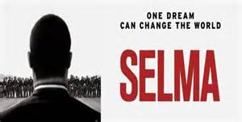

Selma: The Bridge to the Ballot “The unforgettable true story chronicles the tumultuous three-month period in 1965, when Dr. Martin Luther King, Jr. led a dangerous campaign to secure equal voting rights in the face of violent opposition. The epic march from Selma to Montgomery culminated in President Johnson signing the Voting Rights Act of 1965, one of the most significant victories for the civil rights movement. Director Ava DuVernay's "Selma" tells the story of how the revered leader and visionary Dr. Martin Luther King, Jr and his brothers and sisters in the movement prompted change that forever altered history.” From www.imdb.com

Saturday, January 23, 2:00 p.m.
Summers Auditorium
Parkersburg/Wood County Library
Free and open to the public

►Spread the word to friends and other organizations that they are invited to join us for this event.
►Assistance will be available for people who want to register to vote online. (Note that a driver’s license or state issued photo ID is required for online registration.)
Voter January 2016

WV Legislature

Session opens Wed. January 13, closes Sat. March 12
Live streaming is available at http://www.legis.state.wv.us/

WV Public Television will provide live coverage. See “The West Virginia Channel” at http://wvpublic.org/

It’s too soon to know what will get attention this session, but the Legislature is expected to again consider a forced pooling bill that died on the last night of the 2015 session. There’s a big hole in the state budget to be filled. Interim committees meeting Jan. 10-12 have talked about drug testing for welfare recipients, the establishment of a state earned income tax credit, and changes in state ethics laws. Stay tuned in.

LWVWV LEGISLATIVE PRIORITIES

The LWVWV Board has adopted its 2016 legislative priorities. Each member of the legislature will receive a letter including the League’s priorities.

The League of Women Voters of West Virginia:

- Supports reforms of the WV tax system that are broadly based, rely on diverse revenue sources, provide an adequate, stable yield, and treat taxpayers equitably.
- Supports strengthening disclosure requirements for the sources of political campaign expenditures, including independent expenditures and election-related communications.
- Supports measures that encourage investment in energy efficiency in West Virginia’s homes, businesses, and industries.
- Supports expanding the availability of services for people who need treatment for mental illness or substance abuse.

Our February 22 meeting will be an update on the ongoing legislative session, emphasizing issues important to the LWV.

Page 2 January 2016 LWVWC Voter

2016 Election Calendar
- April 19 Voter registration deadline
- April 27 – May 7 Early voting
- May 10 Primary Election Day
- October 18 Voter registration deadline
- Oct. 26 – Nov. 5 Early voting
- November 8 General Election Day

VOTERS’ GUIDE – Got a Question?

In planning for a Voters’ Guide for the May 10 Primary Election, we need a lot of questions for candidates. The state board supplies questions for state level offices. We will need questions for candidates for local offices: county commission, sheriff, assessor, county clerk, circuit clerk, circuit court judge, family court judge, magistrate, board of education, mayors, city councils, board of education, and soil conservation district supervisor.
If you have suggestions for questions (or just topics) for any or all offices, please send them to Lydia Cobranchi at Lydia@cobranchi.com. Please note which office and which city if applicable.

Note that the May Primary is the final election for judges and magistrates and for board of education, all of which are nonpartisan elections.

Our lives begin to end the day we become silent about things that matter. Martin Luther King, Jr.
The Birthday of Martin Luther King Jr. holiday is marked on January 18 this year. The first observance of this federal holiday was in January 1986.

LWV of Wood County
25 Lynnwood Dr.
Vienna WV 26105

Movie: Selma: The Bridge to the Ballot Saturday, January 23

January 2016 Voter

Membership in the LWV is open to all citizens of
voting age. To join the LWVWC, send a check
payable to LWVWC for $45 (plus $25 for each additional
member at the same address) to the LWVWC Treasurer,
1 Fox Hill Dr., Parkersburg WV 26104
Write “dues” on the memo line.
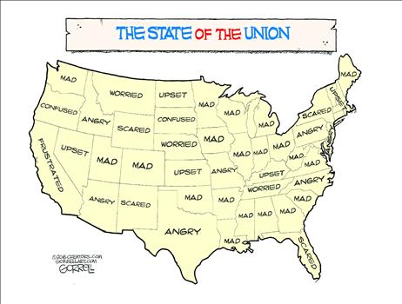

Some New Year’s Resolutions to improve the
health of our democracy
- Attend a meeting of your city council, the board of education, and/or the county commission.
- Write a letter or call a legislator and tell him or her what issue you want to see action on.
- Volunteer to work for the candidate or party of your choice this election year.
- Help someone get registered to vote.
- Give someone a ride to the polls on Election Day.
- Take time to read up on both sides of an issue important to you.
- Send a contribution to a candidate you support.
- Bring a friend to a League meeting and invite him or her to join the LWV.

