League of
Women Voters
Of Wood County WV

President: Charmaine Dotson 304-428-1076, cyde62@suddenlink.net
Local Voter: Kathy Stoltz, 304-295-7880, ksstoltz@suddenlink.net
LWVWV www.lwvwv.org LWVUS www.lwv.org

Mark Your Calendar

Tuesday, Mar. 24 Annual Meeting at J. P. Henry’s
5106 Emerson Avenue, Parkersburg
Monday, April 13 7 p.m. LWVWV Board Meeting
Parkersburg/Wood County Library
Saturday, April 18 LWVWV State Convention in
Huntington. See column to right
Monday, April 27 Membership Meeting – to be announced
LWVWC Annual Meeting
Tuesday, March 24

We’re trying something new this year, moving our annual meeting to J. P. Henry’s, where you can order what you want from the menu.

Our guest speaker will be Cecil Childress, who was until recently the chairman of Downtown PKB, a program dedicated to promoting the historic and economic redevelopment of Downtown Parkersburg.
Mr. Childress is an enthusiastic supporter of developing the downtown district as a multi-use city center, which he writes about in his column in The Parkersburg News & Sentinel. He is general manager of the Blennerhassett Hotel and is reported to be an entertaining speaker.

We’ve asked Mr. Childress to tell us about what he foresees as the future of the downtown area.
Note the following about arrangements for the dinner.
- Be there at 5:45 and take seats in the banquet room. Servers will take your orders.
- Diners will choose and pay for their own meals. Note that for large parties like ours, an 18% gratuity will be included on your bill.
- After ordering, you can mingle and/or visit the bar. Dinners will be served about 6:30.
- In order to know how many we’ll need tables for,
please send names of those who will attend to marionweiser@gmail.com. If you don’t have email, call her at 304-428-3608.
- Dinner and the speaker will be followed by a brief business meeting to elect officers, adopt a budget, and adopt local program. Proposed business items were in the February Voter. .
Voter March 2015

LWVWV State Convention
April 18

The biennial State Convention of the League of Women Voters of West Virginia will be held on Saturday, April 18, 2015, from 10 a.m. to 3 p.m., at the Barboursville Mall in Huntington.
The luncheon speaker will be Ted Boettner, Executive Director, WV Center for Budget and Policy. Mr. Boettner and his organization have worked together with the League on numerous issues in the legislature, such as children’s issues.
“The West Virginia Center on Budget and Policy is a policy research organization that is nonpartisan, nonprofit, and statewide.
The Center’s research and analysis is designed to support informed public dialog and policy in West Virginia. The Center consults and collaborates with other organizations to ensure that its analyses are relevant and timely and strives to be a knowledgeable and respected source of credible information on public budget and fiscal issues for policymakers, advocates, media, and the public.” www.wvpolicy.org
If you are interested in attending as a delegate, contact the president at cyde62@suddenlink.net or call her at 304-428-1076.

OR

Several members have opted to receive their Voter via email, saving the League the cost of copying and postage. This also lets you save the Voter electronically and not have to keep track of a paper copy to check meeting dates and locations. It will be sent as an attachment in two formats so that people with older software will be able to open it.
If you would like to join the email list, send a message to ksstoltz@suddenlink.net and put Voter on the subject line.

DUES: Our League year runs from April 1 – March 31. so unless you have paid your dues since January 1, it’s time to renew. If attending the annual meeting on March 24, you can bring your checkbook and take care of it then.

Page 2 March 2015 Voter

95 Years of Women’s Suffrage

Advocates of women’s suffrage persuaded the WV Legislature to put a suffrage referendum on the ballot in 1916. The voters (obviously all male) rejected it, but the suffragists didn’t give up.
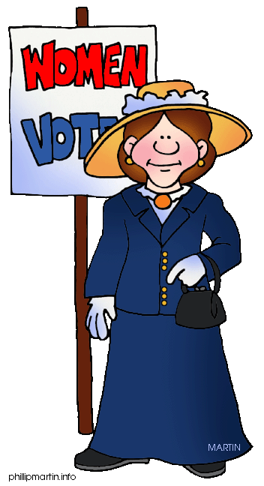
After the 19th Amendment to the US Constitution was proposed in 1919, suffragists lobbied for ratification by the WV Legislature. On March 3, 1920 the House of Delegates voted for ratification. On March 10, 1920 the Senate agreed by a vote of 15-14. WV was the 34th of the 36 states required to make the amendment part of the US Constitution.
(Source http://www.wvculture.org/history/suffrage.html)

In recent WV elections, women comprise the majority of those voting. Sadly, most registered voters don’t bother to vote.
---------------------

We the People
The LWVUS joined civil rights organizations in issuing the People's Voting Rights Manifesto in honor of the 50th Anniversary of Bloody Sunday and the Selma to Montgomery March on March 8, 2015. This declaration was distributed at the re-enactment of the Selma March and the celebration of the Voting Rights Act.
It begins: We the People of these United States, to finally form a more perfect union, recommit to restore the letter and the spirit of the Voting Rights Movement, symbolized by the blood that was shed on this Edmund Pettus Bridge.
Read the full text at: http://lwv.org/content/league-joins-peoples-voting-rights-manifesto

LWV of Wood County
25 Lynnwood Dr.
Vienna WV 26105

Annual Meeting
Tuesday, March 24
at J. P. Henry’s

Membership in the LWV is open to all citizens of
voting age. To join the LWVWC, send a check
payable to LWVWC for $45 (plus $25 for each additional
member at the same address) to the LWVWC Treasurer,
1 Fox Hill Dr., Parkersburg WV 26104
Write “dues” on the memo line.
Legislative Update

The February 23 Legislative update meeting was well-attended by an enthusiastic group. Obviously League members care about what happens in the legislature.
Action will be fast in this last week of the session, which ends Saturday at midnight. We’ve already seen bills amended from bad to good to bad again in the space of a day or two, seen a governor’s veto overridden for the first time since 1987, and frankly haven’t seen a lot to make League members smile. There were bits of good news in what wasn’t taken up. Voter ID never got out of committee.
It’s impossible to know what all will become law until the final bang of the gavel and subsequent actions by the governor. We will put together another summary similar to the handout at the meeting after the session ends and get it to members eventually.
If you kept the handout and want to check on what’s happened to particular bills, it’s easy to check bill status on www.legis.state.wv.us. Just put the bill number (digits only, no letters) in the box indicated. Scroll down and get the whole history of the bill’s movement, or lack of movement, through the legislative process.

Live coverage of the final day of the legislative session returns to WV public television and online at www.wvpublic.org on Saturday from 11 a.m. to 5 p.m. and 8 p.m. to midnight.

For a civics lesson on the legislative process, see How a Bill Becomes Law under the Educational tab on the legislature’s website.

